1. How many types (kinds) of pets are there?

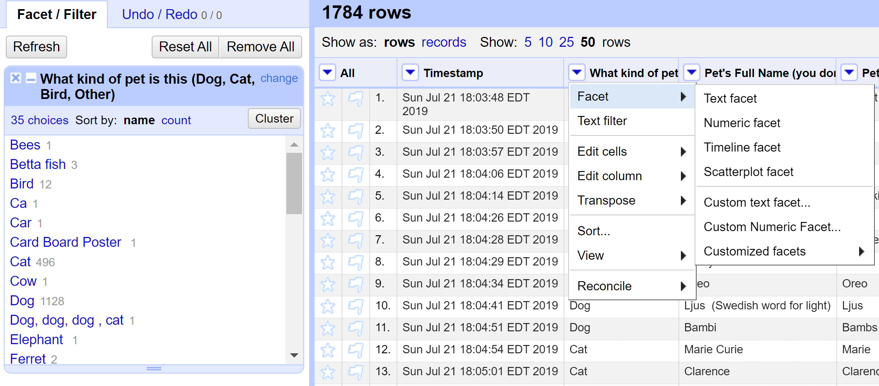

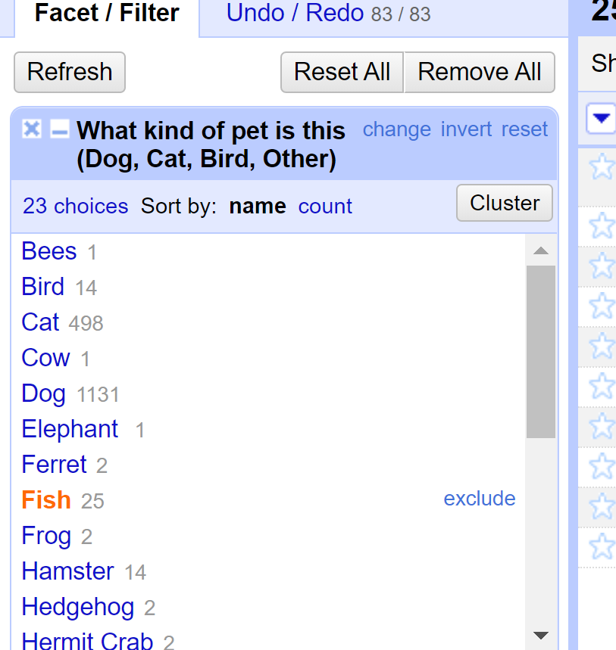

1. How many dogs?







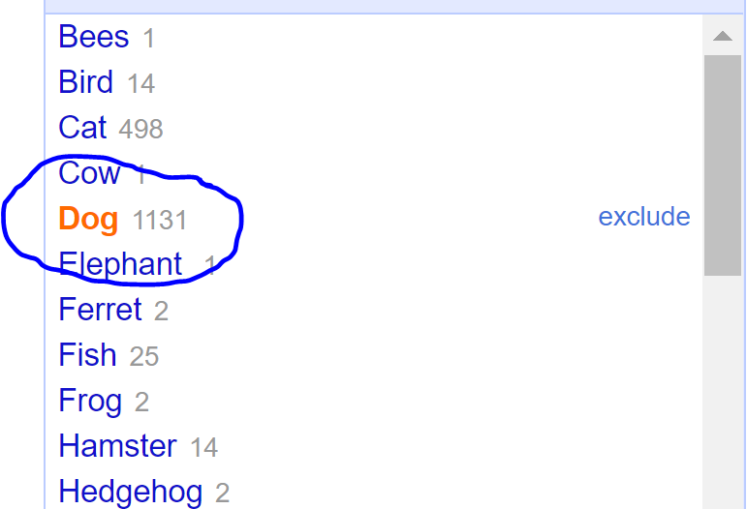

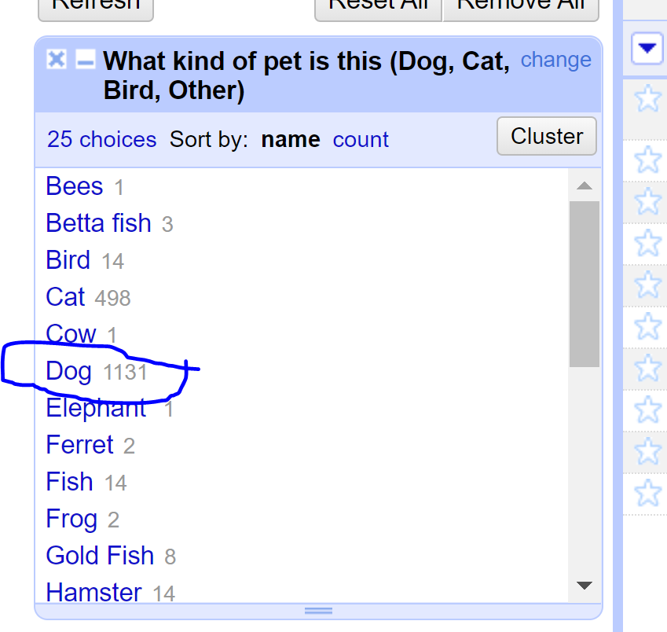

1. How many breeds of dogs?

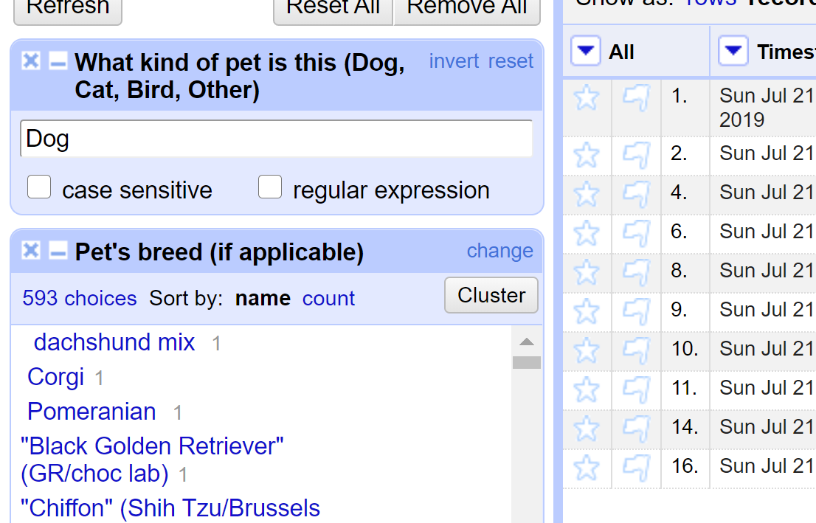



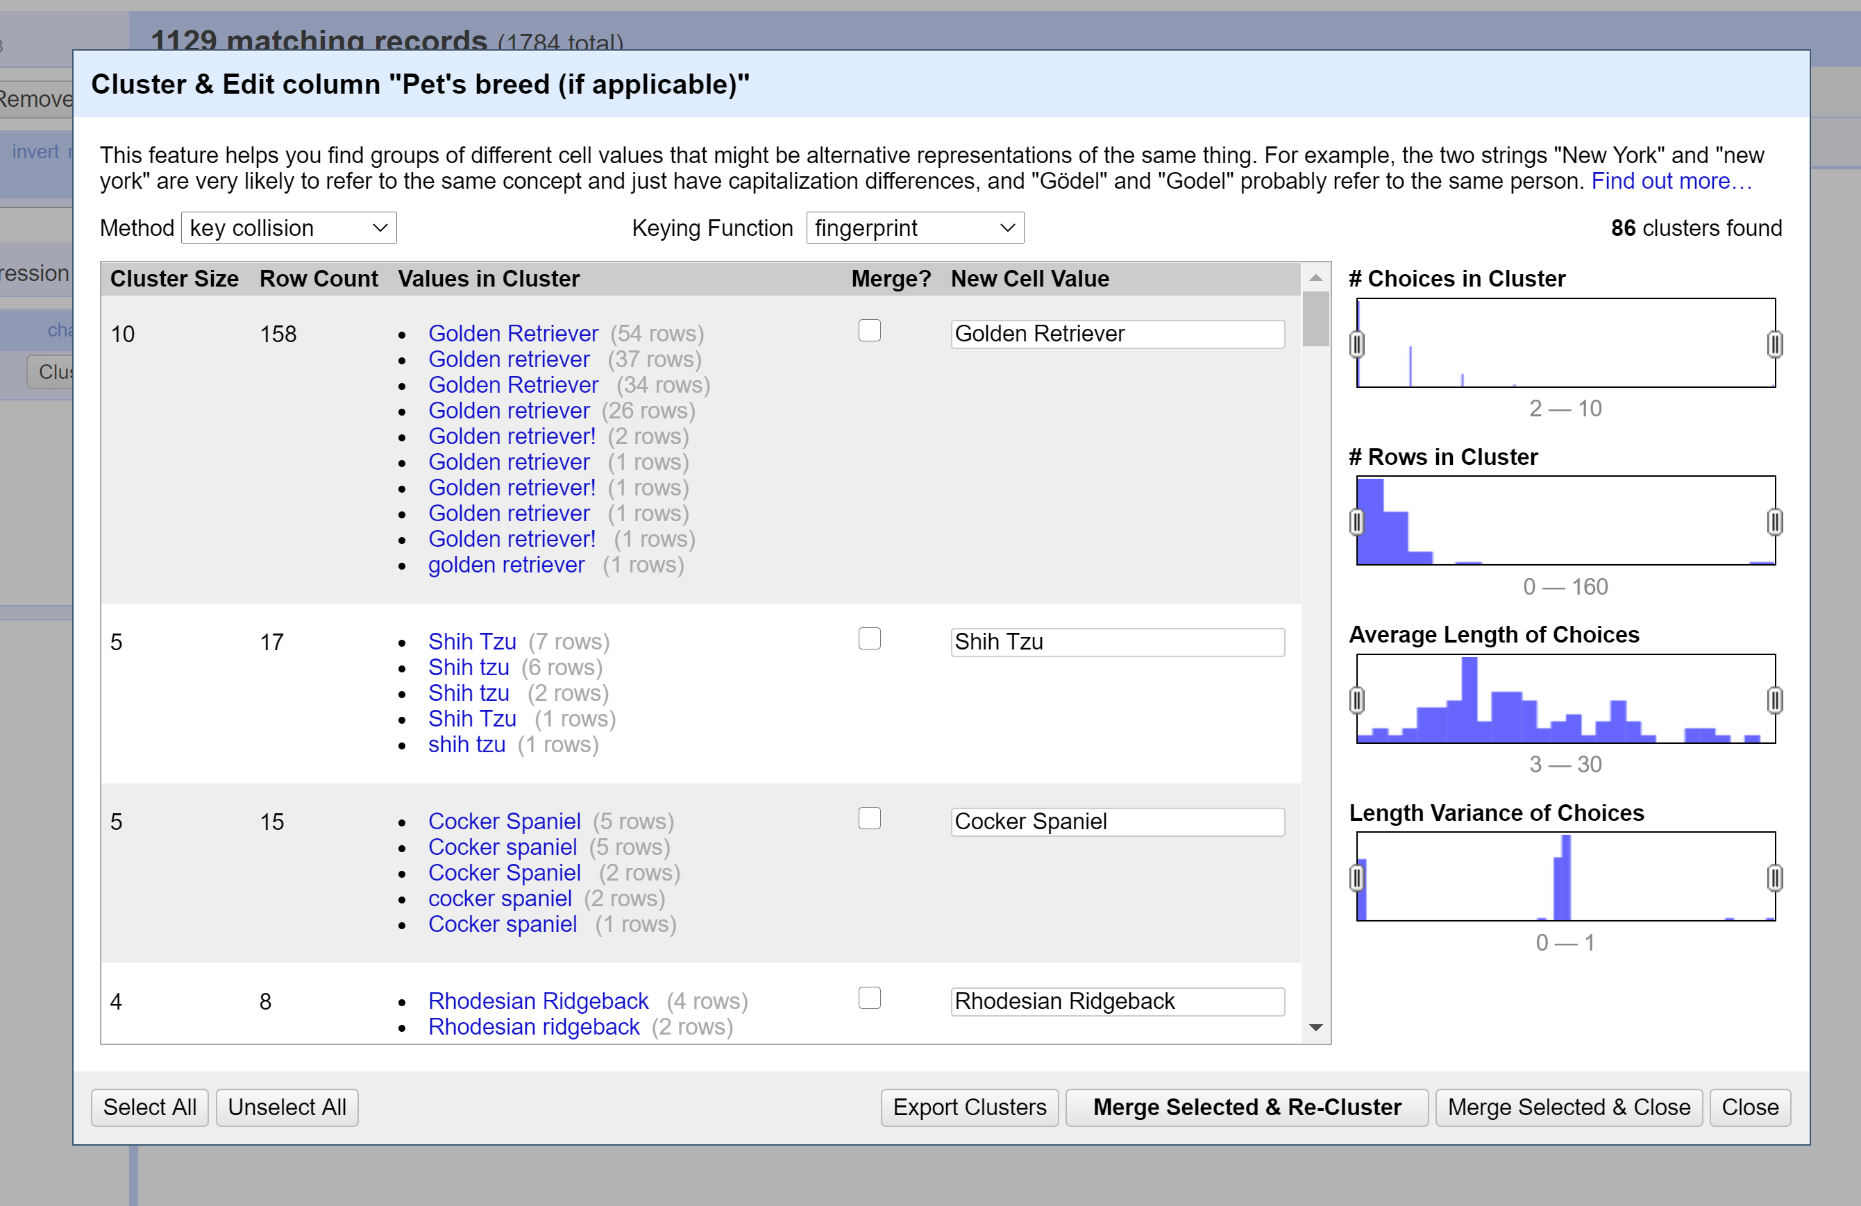

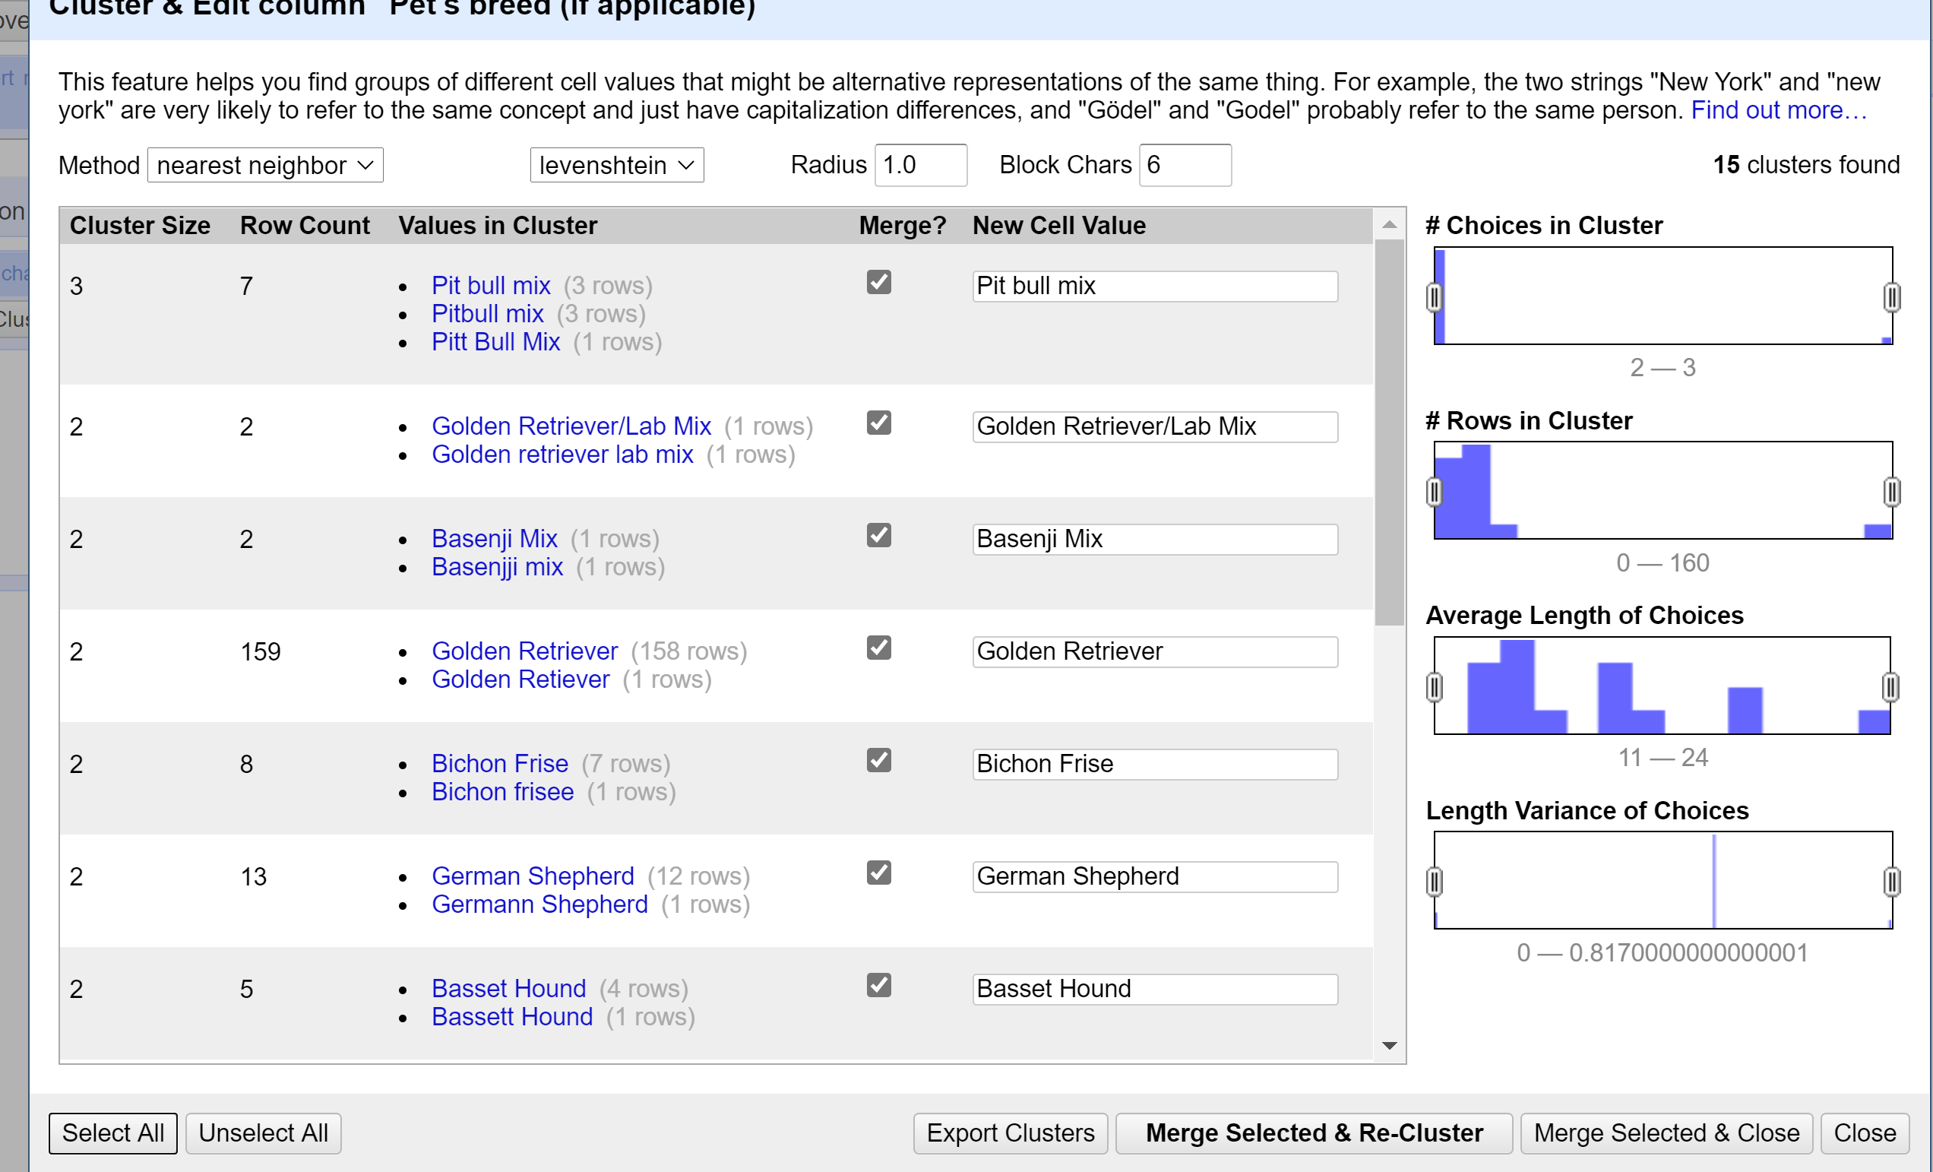

1. What's the most popular dog breed?
2. What's the age range of the dogs?
3. What's the age range of the guinea pigs?

Since Guinea Pig belongs to Rodent family, I considered it as a rodent and of the 7 varieties of rodents in the list there are **13** guinea pigs and the age range is between **1 year and 5 years** ( considering the numbers as years). There is one age value as ~4, I considered it as 4 years (probably it could be 0.4 years also).

To identify the age range of guinea pigs, I considered **Text filter** in “What kind of pet” and considered **Rodent**, then there are different names for guinea pigs, I change all of them as guinea pigs.

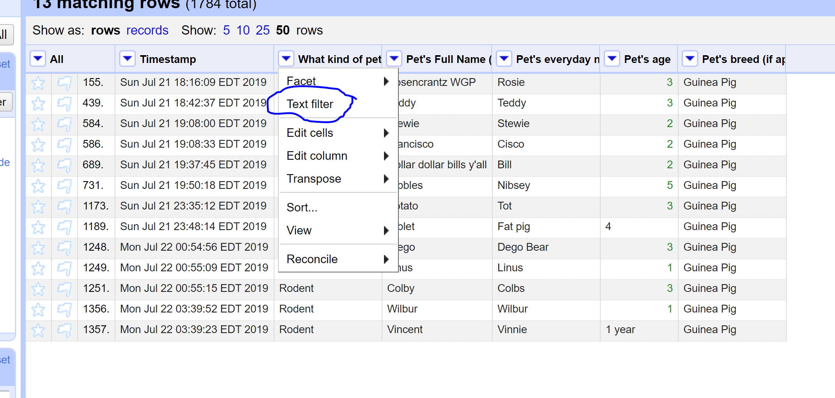

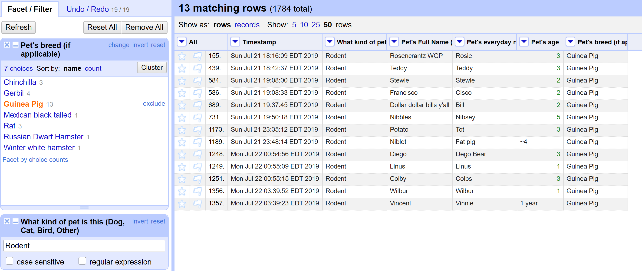

1. What is the oldest pet?

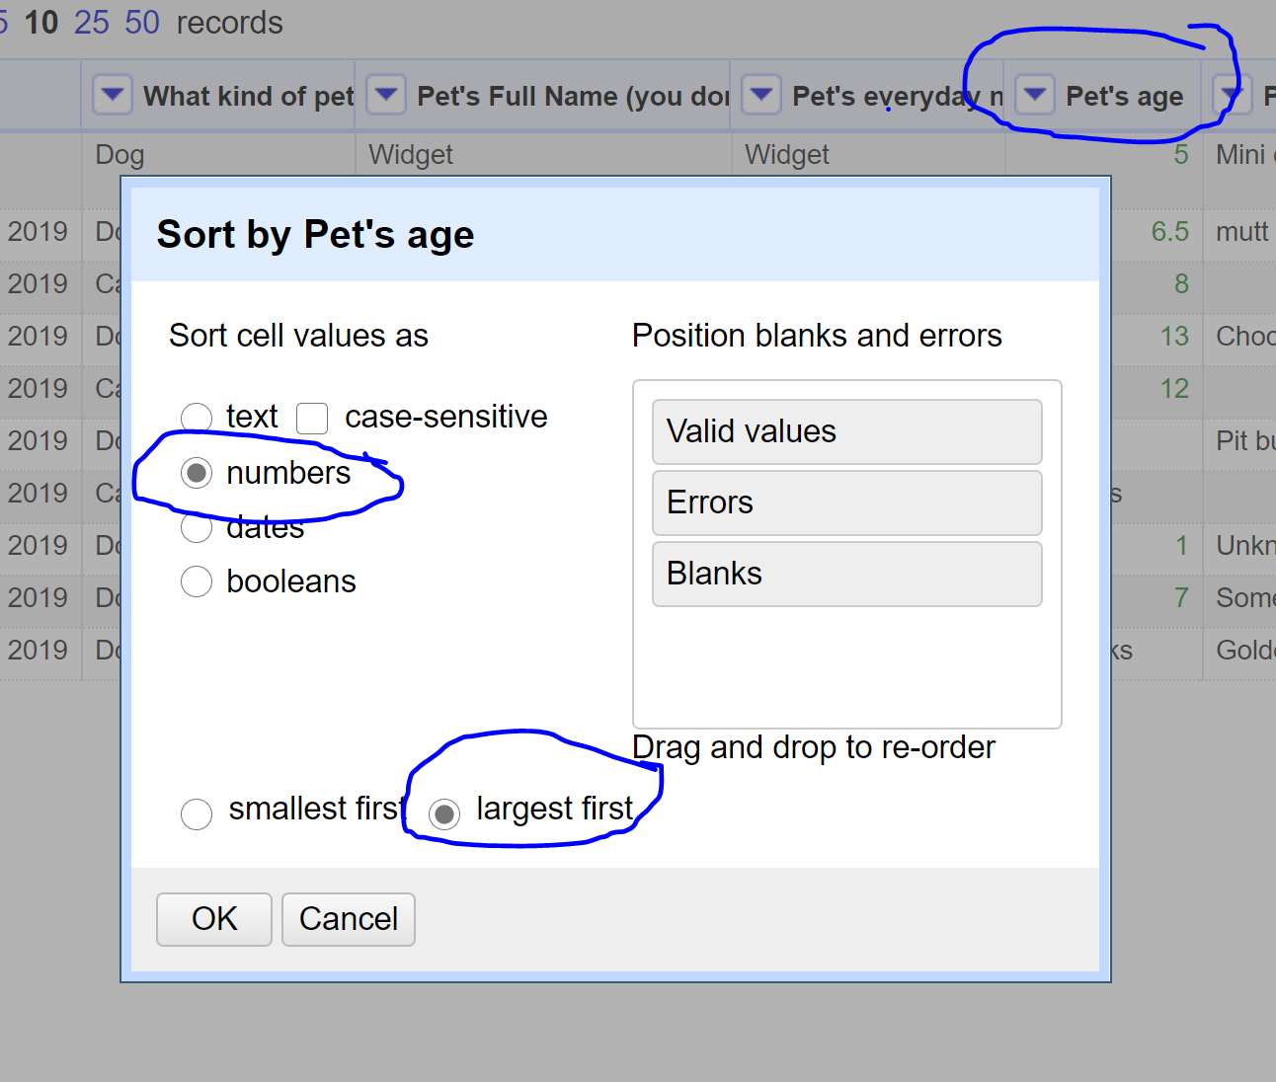

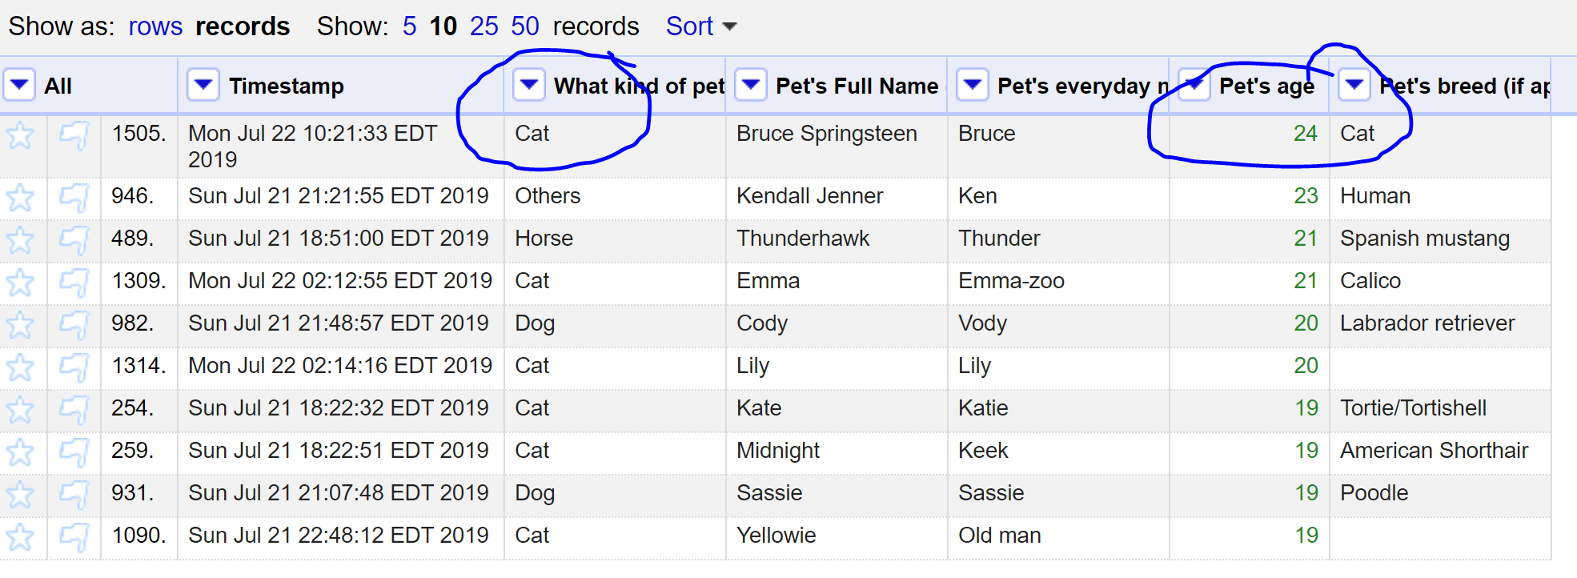

1. Which are more popular, betta fish or goldfish? How many of each?

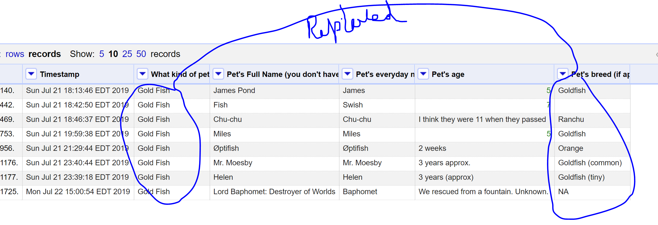

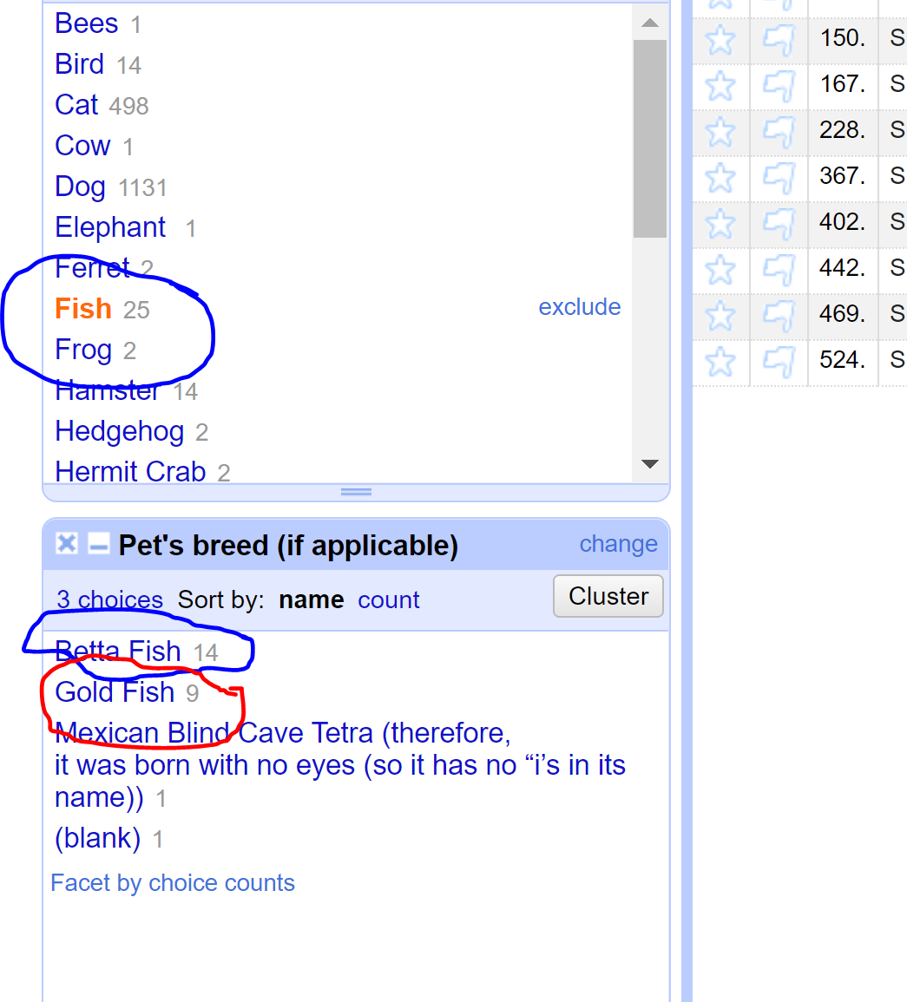

1. What's the most popular everyday name for a cat?
2. What's the most popular full name for a dog?